PROGRAM FOR BOBBIN ON THE MURRAY
FRIDAY 23, SATURDAY 24, SUNDAY 25 AUGUST2019
CHRIST CHURCH ANGLICAN FUNCTION HALL
CNR SPLATT AND Mc CALLUM ST SWAN HILL
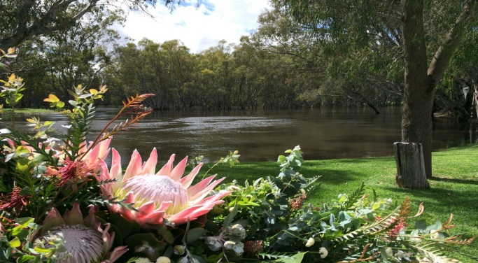
PARKING: Available in the street & Centre carpark in McCallum St.
ACCOMODATION: There are many Motels, Caravan parks and a few B&B’s choose your own.
Friday Meet & Greet 5.30 pm-7.00pm at the Anglican Function Hall
Social Lace: Saturday, 9.30am -4pm. Sunday 9.30am -3.30pm
Saturday Dinner own cost venue to be advised
Please send booking form & cheques to
Yvonne Penny
P.O. Box 477
Swan Hill 3585
OR if direct debit scan & e-mail to malleelace@gmail.com

Any queries: 0438 339 269.
BOOKING FORM
BOBBINS by Britt Fairchild
Order & payment for bobbins due by 25th April 2019
No. of bobbins _______ @ $16 EACH = $_____
_______________________________________________________
SOCIAL LACE COST (Inc. meals as listed) $50
FRIDAY EVENING: Meet & Greet
SATURDAY Lunch, Morning & Afternoon Tea
SUNDAY Lunch, Morning & Afternoon Tea
PARTNERS (See costs below per person)
FRIDAY EVENING Meet & Greet $10 _____
SATURDAY Lunch $15 _____
SUNDAY Lunch $15 _____
YOUR TOTAL FEES payable by 25/07/2019 $______
SATURDAY EVENING A la carte, at local venue TBA, Number attending ____
YOUR DETAILS:
FOOD ALLERGIES _______ _
NAME PHONE No _
E-mail ______________________________
PAYMENT METHOD: DIRECT DEBIT
CHEQUE OR Bendigo Bank. BSB No. 633-000
(Payable to “Mallee Lacemakers”) Account No. 53097259
Account Name: Mallee Lacemakers
Reference “your name”

